Primary layout:
- Keep the current colour combinations and layout. It looks different from other websites.

Headline:
Where AI Meet Business Goals
Sub text:
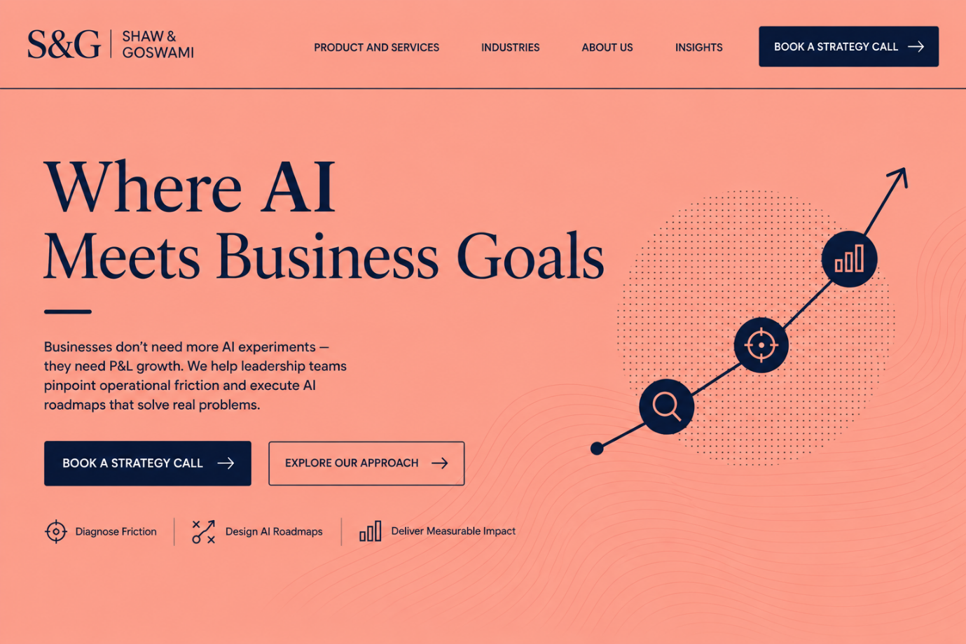

About US
Our Story
AI is changing how businesses operate and grow. Yet, there remains a gap between what AI makes possible and what businesses are actually able to achieve with it.
Leadership teams don't need more AI experiments. They need clarity on where AI fits, which problems are worth solving, and how it can deliver measurable business value.
Shaw & Goswami was built to bridge this gap.
With 40+ years of combined experience across AI, data engineering, product development, and business consulting, we bring technology and business thinking together.

We start with the business—not the technology. We go deep into your operations, identify where the real opportunities lie, and find the right solutions to unlock growth.
Understand the business. Find the right fit. Deliver measurable growth.
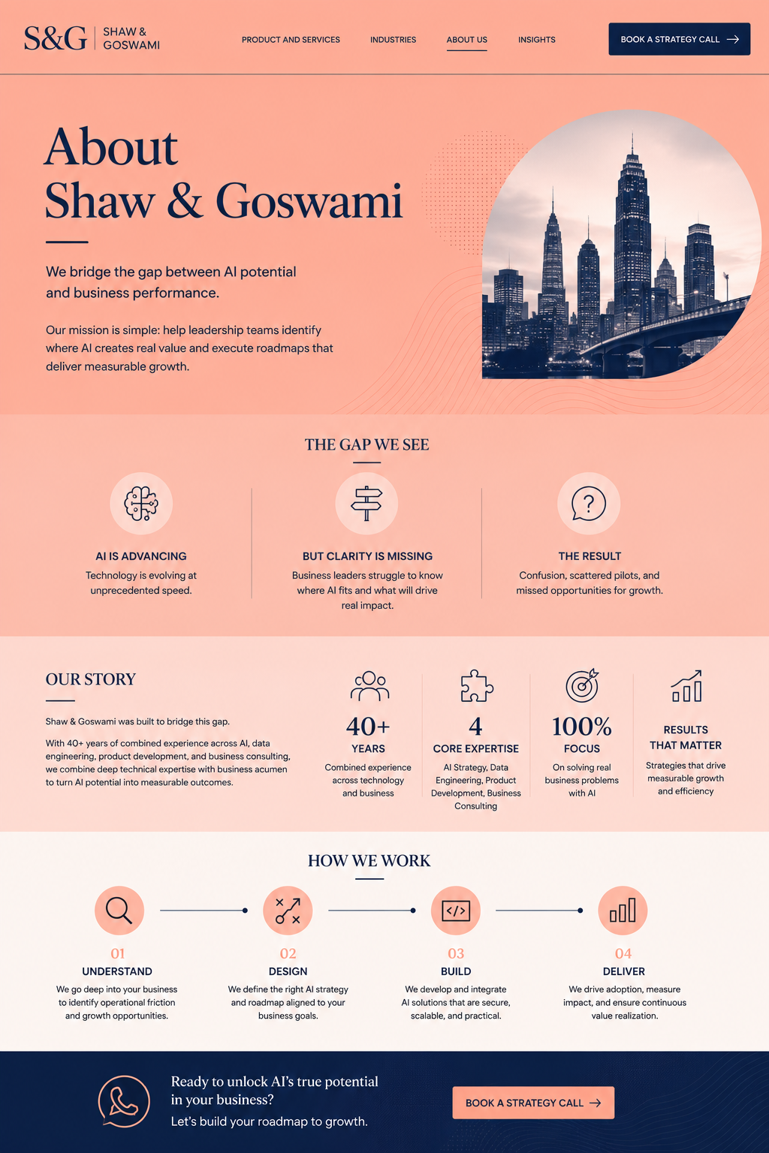

What we do
